**Git-T02-HOL_001**

**Step 1: Setup your machine with Git Configuration**

To create a new repository, signup with gitLub and register your credentials

Login to GitLab and create a “GitDemo” project

1. To check if Git client is installed properly: Open Git bash shell and execute

If output shows Git with its version information that indicates, that Git Client installs properly.

1. To configure user level configuration of user ID and email ID execute
2. To check if the configuration is properly set, execute the following command.

**Step 2: Integrate notepad++.exe to Git and make it a default editor**

1. To check, if notepad++.exe execute from Git bash
2. Exit Git bash shell, open bash shell and execute

Now, notepad++ will open from Git bash shell

1. To create an alias command for notepad++.exe, execute

It will open notepad++ from bash shell, and create a user profile by adding the line in notepad++

1. To configure the editor, execute the command
2. To verify if notepad++ is the default editor, execute the command

Here ‘-e’ option implies editor

**Step 3: Add a file to source code repository**

1. Open Git bash shell and create a new project “**GitDemo**” by executing the command
2. Git bash initializes the “**GitDemo**” repository. To verify, execute the command

It will display all the hidden files in the Git “working directory”.

1. To create a file **“welcome.txt”** and add content to the file, execute the command
2. To verify if the file “welcome.txt” is created, execute
3. To verify the content, execute the command
4. Check the status by executing

Now the file **“welcome.txt”** is available in Git “working directory”

1. To make the file to be tracked by Git repository, execute the command
2. To add multi line comments, we are opening default editor to comment. Execute the command

Notepad++ editor will open and to add multi-line comment with default editor

1. To check if local and “Working Directory” git repository are same, execute git status

**welcome.txt** is added to the local repository.

1. Signup with GitLab and create a remote repository **“GitDemo”**
2. To pull the remote repository, execute

git pull origin master

1. To push the local to remote repository, execute

git push origin master

**The screenshot for the following commands**

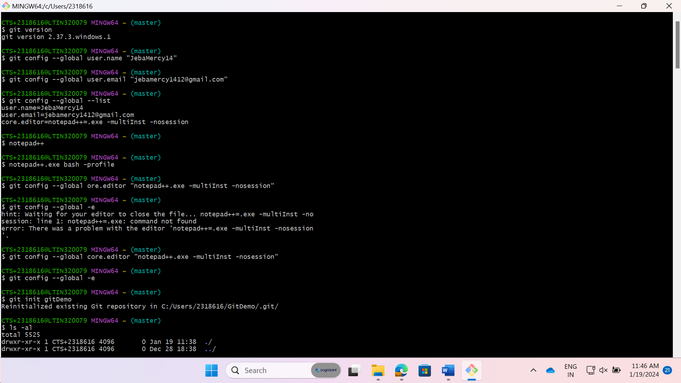

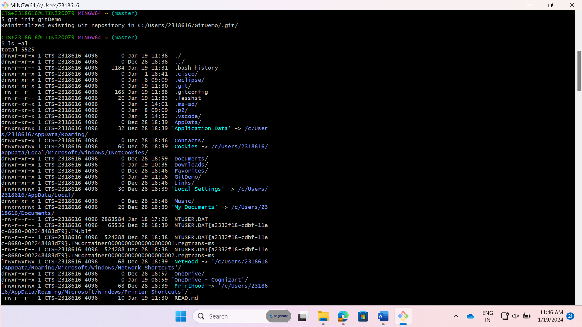

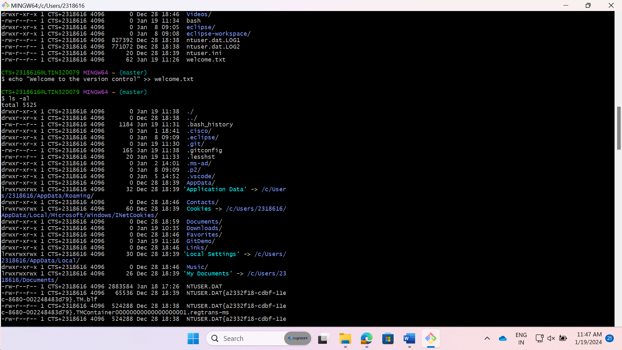

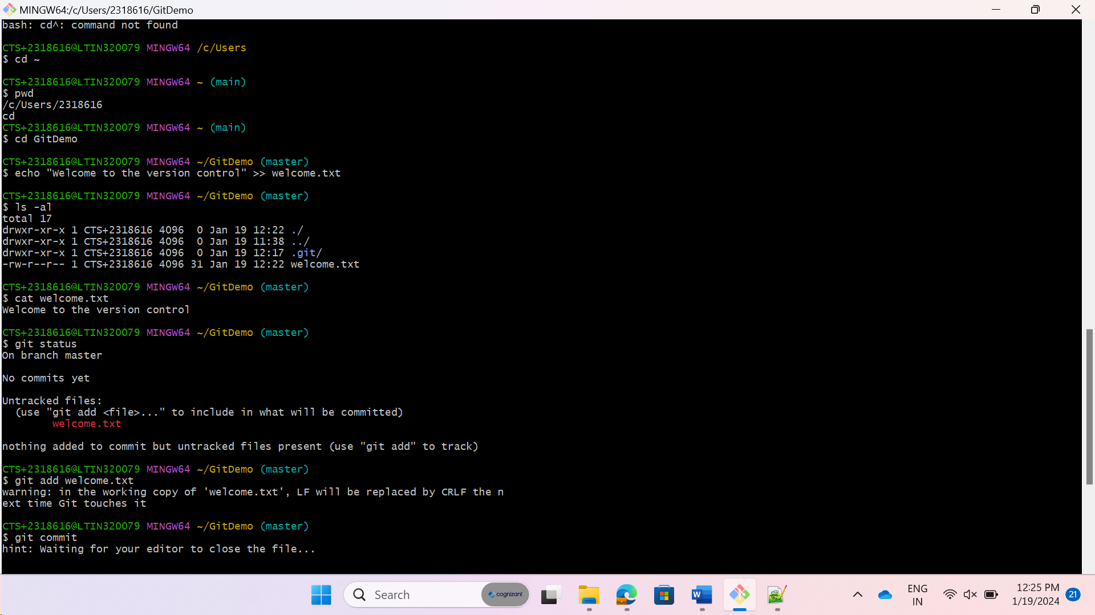

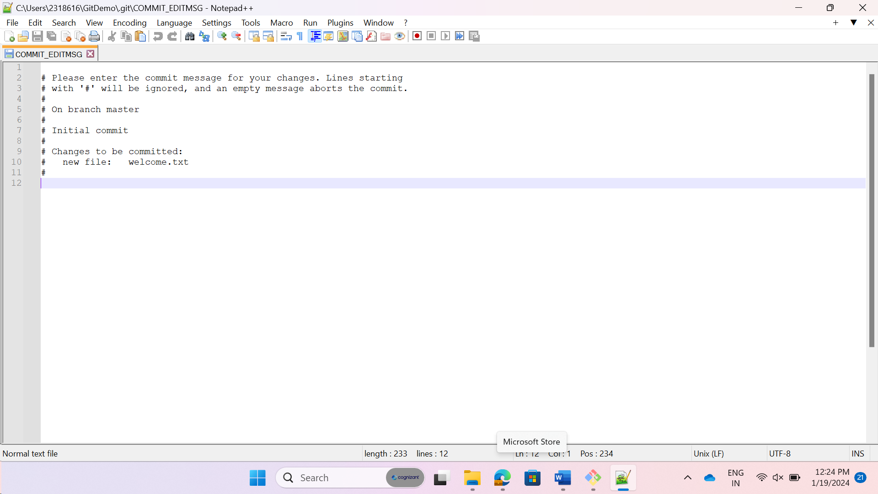

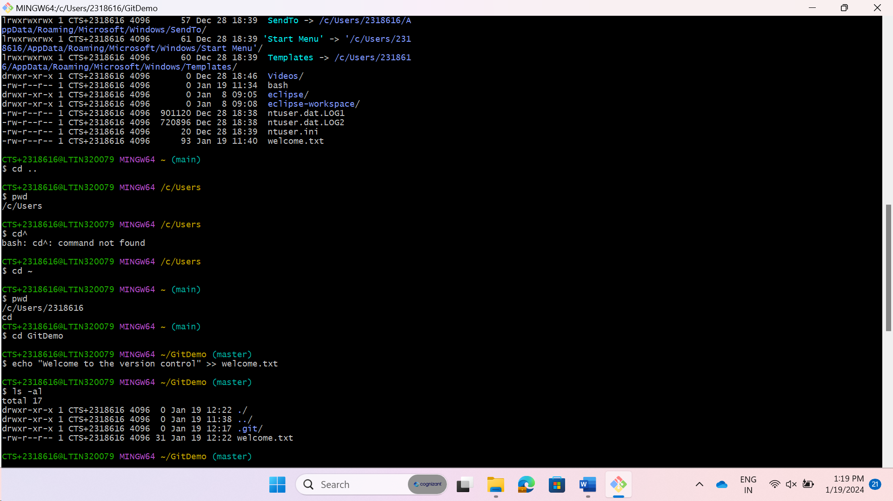

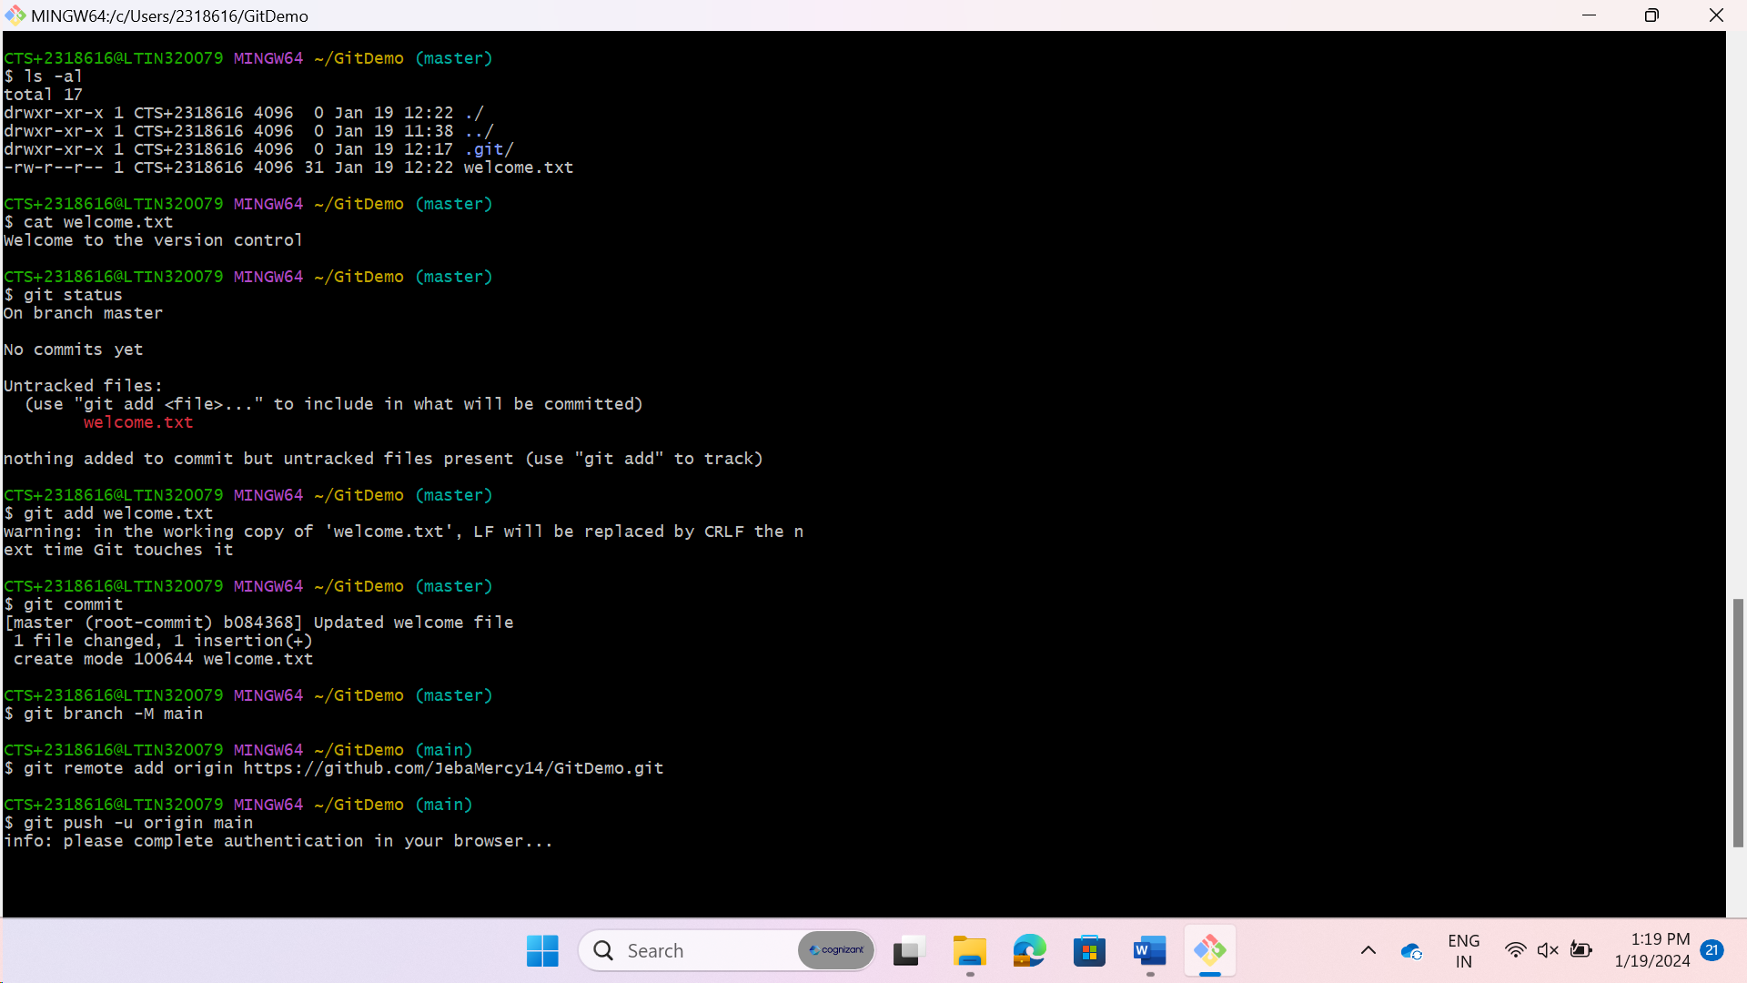

**Final Output**

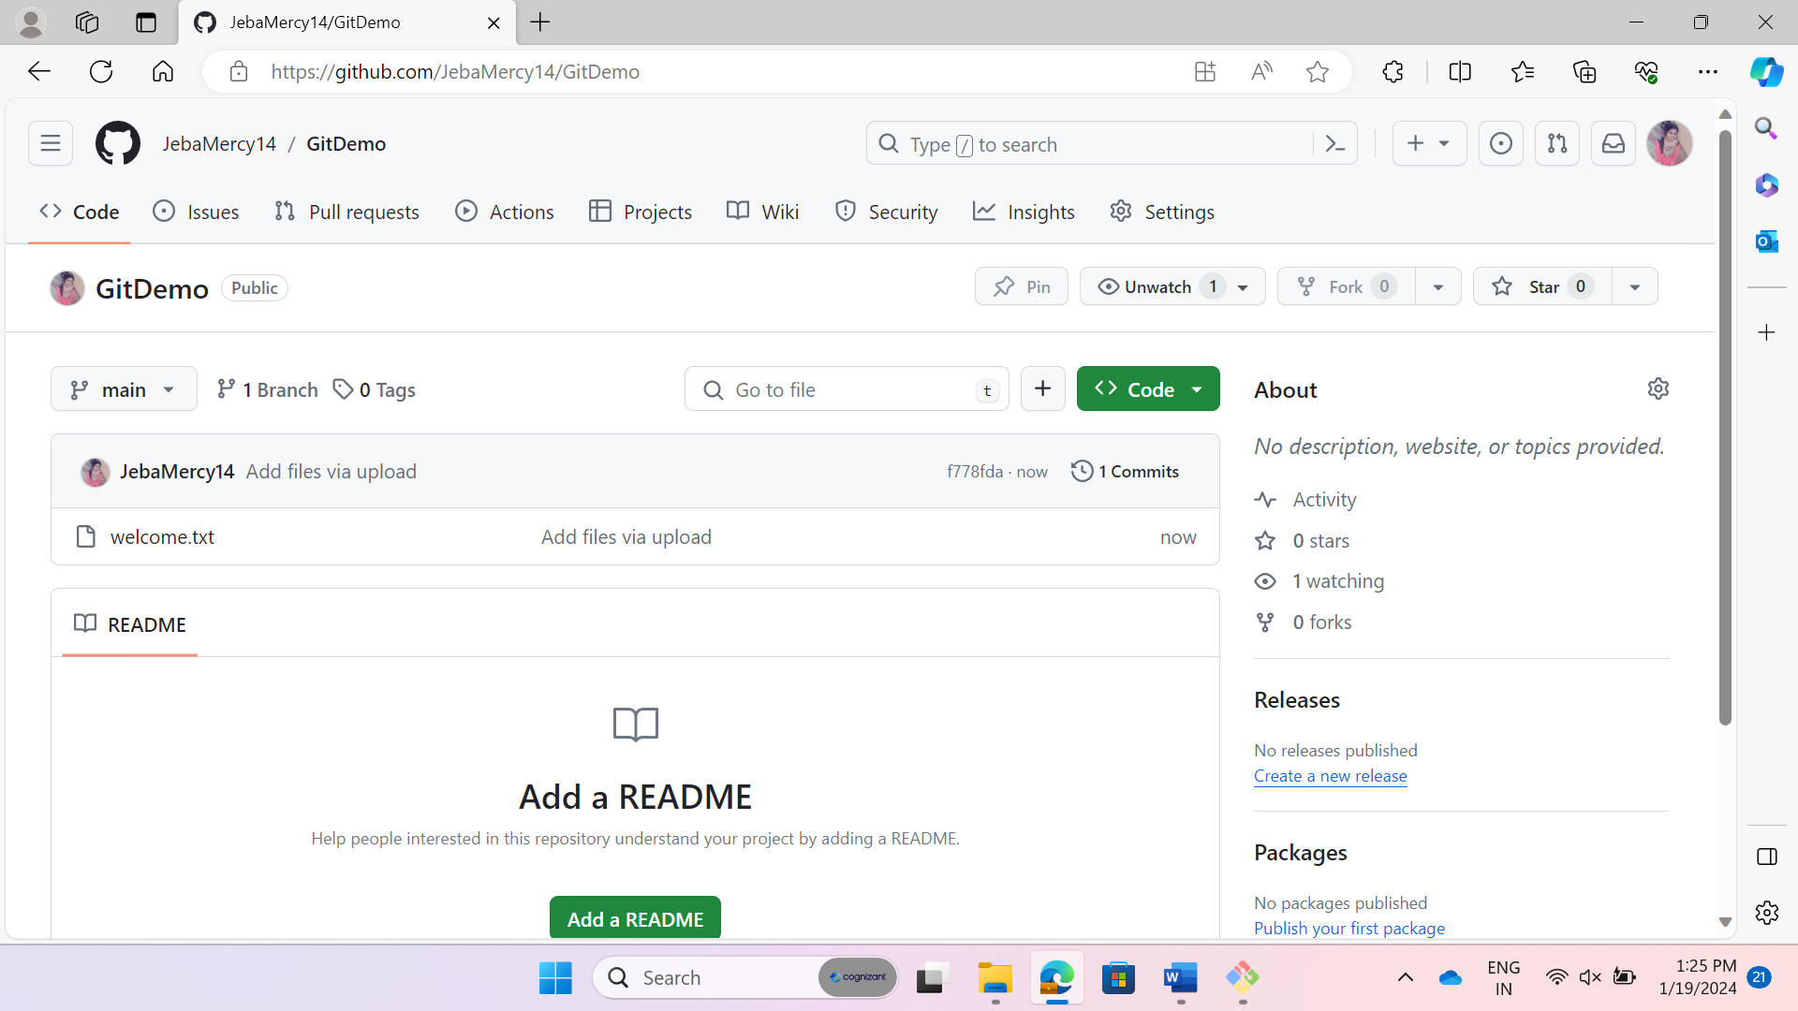

Finally, the required file has been pushed into the GitHub using the git commands.